Would you like to discuss how to approach the migration issue in artistic creations for children?
Could you help us share this video of digital theatre with children all around the world especially the refugee ones?
The CBTIJ/ASSITEJ Brazil is supporting this initiative by spreading the word about

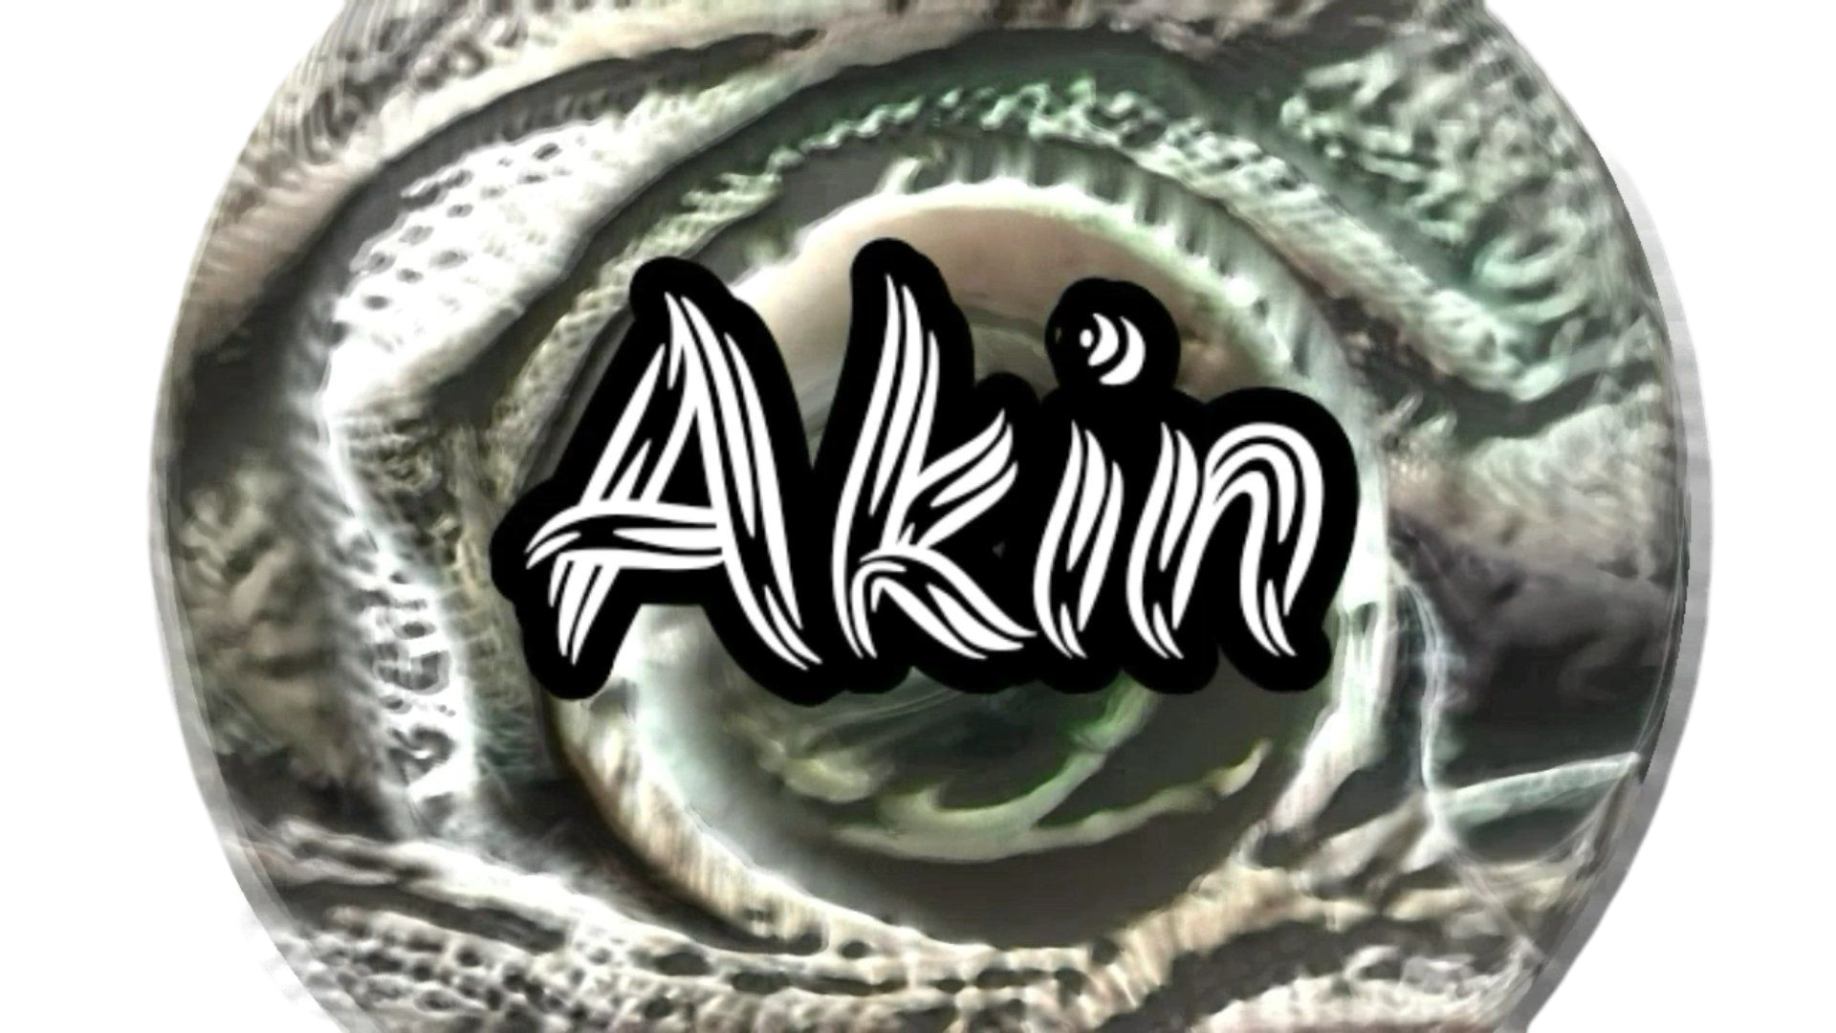
A story for children from everywhere, anywhere.
Project AKIN - a trip about diasporas and childhoods

On September 28, 2020, AKIN premiered on the Bando de Brincantes channel on YouTube. It is a domestic digital theater production that aims to dialogue with children from different places and social situations, especially those from refugee groups. The narrative addresses the theme of the diaspora through a non-verbal language rooted in a pluriperceptive and multi significant composition. Through corporeality, musicality, and plasticity, this play's theatricality emerges from a rudimentary relationship between craftsmanship and technology, based on different elements of the heterogeneous Brazilian culture. The narrative seeks to provide affective perceptions that value the experiences of migration, the diversity of people, and the plural encounter of different cultures.

The plot is about the story of Akin, a child who, after leaving his country, finds himself at the border of a place where only those who submit to the dominant culture are allowed to enter. Akin's journey shows his trajectory towards maturity and reveals the strength he gains when he learns about the different cultures that come his way, in dialogue with his ancestry.

On his journey, Akin experiences different adventures. He materializes a kerchief on his imaginary friend Zhorobodingon and, after many situations, starts to use this adornment on his head, as did the maternal figure, Dodá, at the beginning of the narrative. Akin sees Dodá being arrested with other people who have refused to transform themselves. They are enclosed in the Oppressor's briefcase, which dominates the entrance to the city, whose gate is guarded by a snake that follows his directions. This snake is sent in search of Akin when he escapes the capture of the Oppressor. On the way, Akin meets Sosen no Ki and is initiated into a cultural ritual that fills him with energy and courage. After winning a fight with the snake, Akin undoes the domination that existed over the animal, which manages to return to being Yakto, a reference to Oxumaré and the fertile power of diversity.

In an affective-rational way, the work addresses urgent current issues, such as race, gender, migration, and cultural plurality. The narrative is in line with what the author, Viviane Juguero, calls children's playful logic, in which emotions, perceptions, and rationality are deeply associated through constructions that are different from the abstractions of adult thought.

It should be noted that Akin is a proper name in Yoruba, which means warrior, and an adjective, in English, which can be translated as similar or related. In Portuguese, the name Akin is not associated with a defined genre, which also expands the possibilities for understanding the proposal. These plural perceptions guided the choices of aesthetic construction, related to the materials available in this specific context since the creation of AKIN was carried out in social isolation due to the pandemic COVID-19, in just two months.

The work was entirely filmed in the living room of the apartment where the family of artists Henrique Rosa Juguero, Éder Rosa, and Viviane Juguero resides. The edition, edited on a cell phone, features cloth panels, tree bark masks, and handmade trinkets along with chroma key and stop motion techniques, in addition to several effects elaborated based on photos of objects available in the apartment or in the courtyard of the building where the family resides. The original music, created by Everton Rodrigues, mixed acoustic instruments with technology and was produced in home-studio, respecting the distance imposed by the quarantine.

Relevance

The intense diasporic movements, from the past and the present, have resulted and result in ways of living childhood that are entirely different from the idealized cultural constructions that underlie much of the hegemonic aesthetic creations dedicated to children's groups. Besides, the Brazilian population, predominantly black and brown, hardly has the opportunity to see themselves represented in children's productions that emphasize the diversity, beauty, and strength of our Afro-Brazilianity.

Artistic creations play an essential role in composing the modes of emotion, which underlie values, desires, and socio-cultural relationships. This project aims to provide children with ways of elaborating situations linked to different aspects related to diasporas, promoting perceptions that enable projections of a future based on the valuation of these experiences and the solidarity and empowerment of those who experience them.

It should be noted that, on the one hand, the technical limitations of the scenes in this production are evident. On the other, they can serve as an incentive for new creations that do not have access to the production means of the cultural industry.

AKIN results from the project “AKIN - a trip about diasporas and childhoods,” contemplated in the notice FAC Digital RS of the Secretary of Culture of Rio Grande do Sul. The initiative has the partnership of the Brazilian Center of the International Theater Association for Children and Youth (CBTIJ / ASSITEJ). The intention is to disseminate the work to dozens of countries worldwide for children from different places, and realities, especially refugees, can send comments and perceptions on the topic in a dialogical and creative way. In addition to children, reflections from professionals of Art, Education, and other fields are also welcome and can be sent to brincar@bandodebrincantes.com.br.

This dialogue will contribute to developing the play "Bambu Bambá," which would be held in 2020 in Germany, at dasvinzenz theater, but its assembly was postponed due to the pandemic. The work, whose production was conceived with the dramaturg Bárbara Kastner, should occur after the period in which the family will be in Norway. It will happen due to Viviane Juguero's Postdoctoral position in Performing Arts and Aesthetics at the Faculty of Arts and Education, Department of Early Childhood Education of the University of Stavanger, lasting two years.

AKIN will be available on the Bando de Brincantes channel, on youtube, from September 28, 2020.

TECHNICAL STAFF:

AKIN (video of the play) - https://www.youtube.com/watch?v=jmcUSrYvz5Y&feature=youtu.be

Script and direction: Viviane Juguero

Cast:
Henrique Rosa Juguero, as Akin.
Éder Rosa, as Zhorobodingon, Yakto, Oppressor, and invisible man.
Viviane Juguero, as Dodá and Sosen no ki.

Original music: Everton Rodrigues

Choreographies and body training: Éder Rosa

Scenography, clothing, props, and scenotechnical: Éder Rosa

Masks: Éder Rosa and Sayô Martins

Editing and filming: Viviane Juguero, Henrique Rosa Juguero, and Éder Rosa.

Studio: Sala do apartamento da família (área: 3,70m X 3,15m / altura: 2,62m)

Free classification.

Target audience: children aged 7 to 11 years.

Sponsor: FAC DIGITAL RS

Executive production: Éder Rosa

Realization: Bando de Brincantes
Collective associated with CBTIJ / ASSITEJ

Premiere:

AKIN - digital theatre for children
From September 28, 2020 on at https://www.youtube.com/user/bandodebrincantes

brincar@bandodebrincantes.com.br
www.bandodebrincantes.com.br

