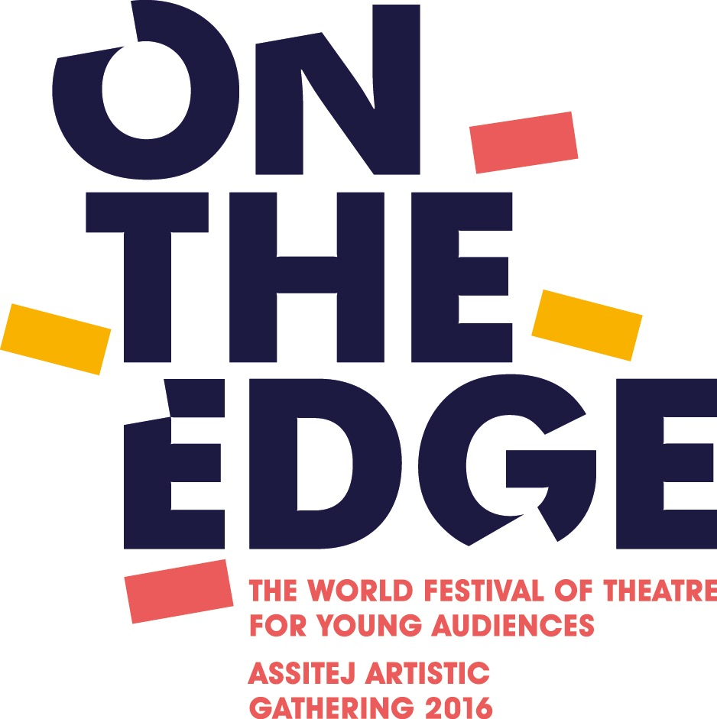

Next Generation / On The Edge
July 2nd – July 9th, 2016 in Birmingham, UK / On the Edge International Theatre Festival for Young Audiences

Application Form

Name:
Street Address/ postcode:
Country:
Phone:
E-Mail:
Nationality:
Do you belong to any institution or company if so which one:
Date of Birth:
□ male □ female □ prefer not to say

Are you disabled and/or have any access requirements?

Please provide a summary of your experience or practice: (100 words)

Please explain what you would hope to gain by participating in the Next Generation Programme. (Max. 100 words):

What would you share with other NG participants regarding your experience, practice or culture? (Max 100 words)

Are you a member of ASSITEJ:

Signature Date

Deadline for the application: September 30th, 2015
Please send the application via e-mail to: ng@ontheedge2016.com

