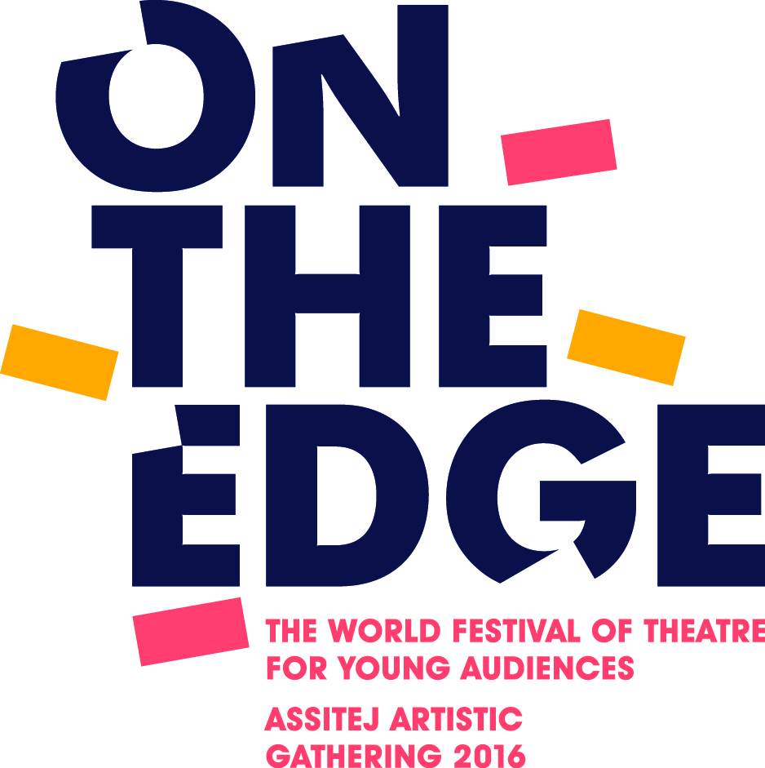

Submitting a Symposium Proposal for Review.

- Presentation Type (please tick):
- Lecture
- Seminar Paper,
- Panel Presentation
- Workshop.

- Short Description:
Provide a short summary of the main idea of your proposal. This will appear in the Programme and give information other delegates can use to choose to attend your session.

(50 words maximum)

- Longer Description:
Provide a concise description of the purpose, methods and implications of your work/ observations/ analysis. Why is it on the edge?
This will be used to evaluate and place your work in the appropriate section.

(150-200 words maximum)

- Theme Selection.
Choose the theme/ area of work which best categorises your work. Theme selections will be
used to begin the process of organising presentations into sessions.

- Knowledge focus.
Please tick to indicate if the focus of the work is Practice, Research or if the work crosses any such boundaries.

Practice | Theory
Research | Boundary Crossing

- Language:
If possible, please submit the above information in English. However, those chosen to present will have translators available should they be required. Please state which language, if other than English, will be used:

- Please complete and submit along with a Details of Proposer Form

Deadline for submissions: 30th September 2015

Please submit by email to: symposia@ontheedge2016.com

