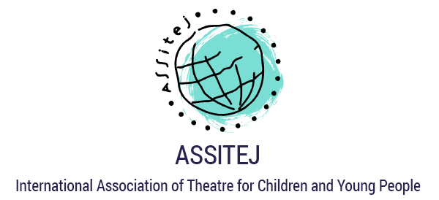

PRESS RELEASE

World Day of Theatre for Children and Young People,

March 20th, 2017

ASSITEJ (French acronym - Association Internationale du Théatre pour L´Enfence et la Jeunesse) is the only association of its kind connecting thousands of theatre makers, artists, educators and producers dedicated to theatre for children across the world.
ASSITEJ has members in over 80 countries across the globe, including 75 National Centers. On March 20th, the global campaign #takeachildtothetheatre advocates for the cultural entitlement of children to have access to spaces for creative play, performance, theatre and expression.

March 20th is ASSITEJ World Day of Theatre for Children and is celebrated worldwide through the campaign Take a Child to the Theatre

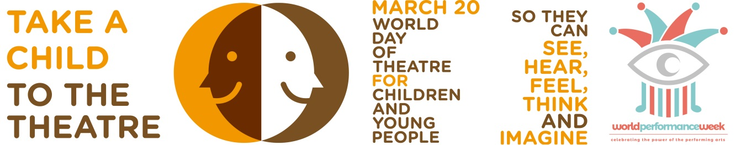

This year’s message has been written by Francisco Hinojosa one of Mexico’s leading authors of children’s literature. In 1984 he won the IBBY Prize for his book La Vieja que Comía Gente (The Old Lady who Ate People) more info can be found here
http://www.assitej-international.org/en/2017/02/2017-world-day-message/
A message has also been written by President of ASSITEJ Yvette Hardie from South Africa.
http://www.assitej-international.org/en/2017/02/world-day-message-2017-by-yvette-hardie/

Francisco Hinojosa says:
‘A story well-told on stage doubtless captivates the children in the audience and somehow transforms them. Leaving the theater after a show, the world seems different: it has been touched by a performance that allows members of the audience to see beyond the surface’.

ASSITEJ President Yvette Hardie says:
‘Children cannot take themselves to the theatre. The World Day of Theatre for Children and Young People celebrated every 20th March is a call to recognize the dependence of children on the adults around them if they are to have critical exposure to the arts in general, and to live theatre in particular. For this reason we say “Take a Child to the Theatre Today”.

Read the full World Day Messages here:

http://www.assitej-international.org/en/the-world-day-of-theatre/
These are also available in Spanish and Portuguese

http://www.assitej-international.org/es/dia-mundial-del-teatro-para-ninos-y-jovenes/

See the promotional ASSITEJ World Day 2017 Film made by our ASSITEJ Norway colleagues here:

https://youtu.be/jWlzKbeDidc
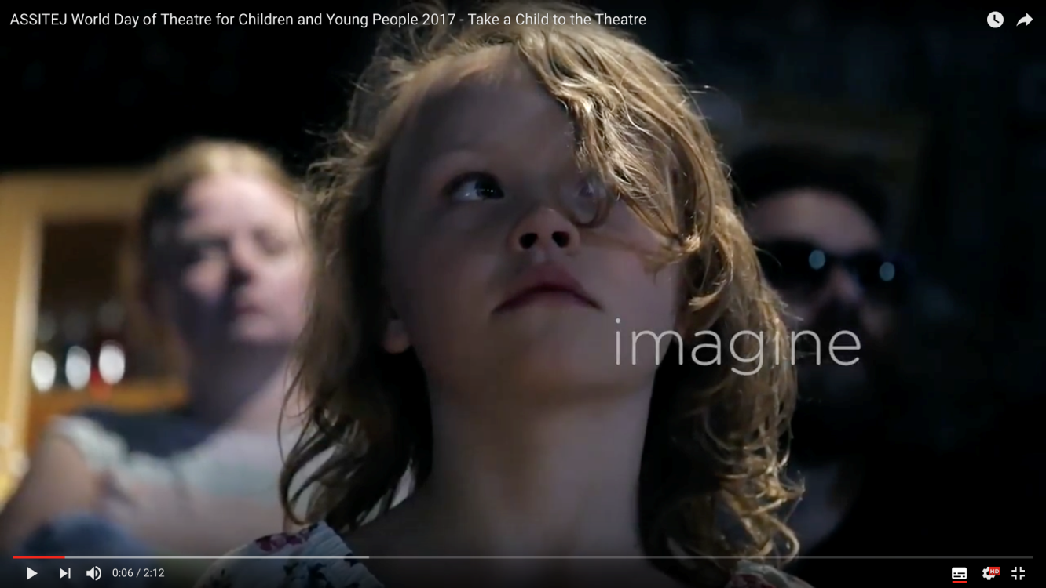

Examples of Activity Celabrations across the world;
Write Local Play Global and Scènes d’enfance-ASSITEJ France launch the 4th edition of A day for a play, the TYA instant playwriting game open to TYA lovers around the world.
ASSITEJ Brazil will celebrate its 3rd CBTIJ Theatre Award ceremony as well as the National Center’s 21st anniversary with a special event showcasing 10 TYA productions.
ASSITEJ Iceland will create an online video message with messages from actors and theatre makers that have shows for young people in Iceland.
ASSITEJ Mexico celebrates its 10th Theatre Marathon, which will be a special one given the 10-year anniversary. The city of Guadalajara will also join the celebrations with activities in Theatre Alarife.
ASSITEJ Poland will provide kids living in the Centre for Foreigners in Warsaw with a chance to participate in the show The Ugly Duckling, performed by students of the Halina and Jan Machulski's Acting School.
TYA USA promotes a Theatre in Our Schools Campaign during March.
ASSITEJ South Africa invites all its members to provide free or partially sponsored performances to children and young people. In 2016 this initiative reached over 15 000 children in the period February to April.
ASSITEJ Switzerland and “Jungspund” theater festival for young audiences, organizes in cooperation with “TheaterLenz” the event «Which possibilities does the theatre offer for children and youngsters for the everyday life at school?»

For 2017, ASSITEJ links with ITI and UNIMA celebrating the power of performing arts, through the new initiative of World Performance Week joining World Day of Theatre for Children (March 20), World Puppetry Day (March 21) and World Theatre Day (March 27).

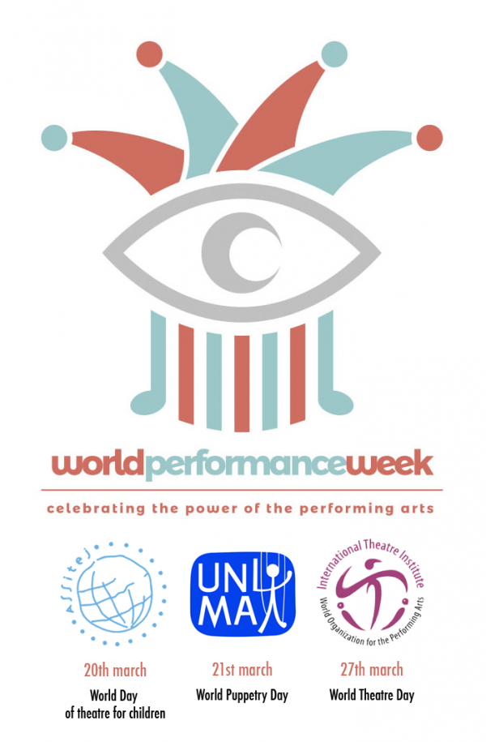

Ends
For further information, interviews or images contact Nina Hajiyianni, Chair of Communications on +44 7802874489 or email nina@assitej-international.org or Marisa Giménez Cacho, Secretary General on (52) (55) 10 00 46 22 ext.1564 or sg@assitej-international.org

http://www.assitej-international.org
www.facebook.com/Assitej.International
https://twitter.com/ASSITEJ

