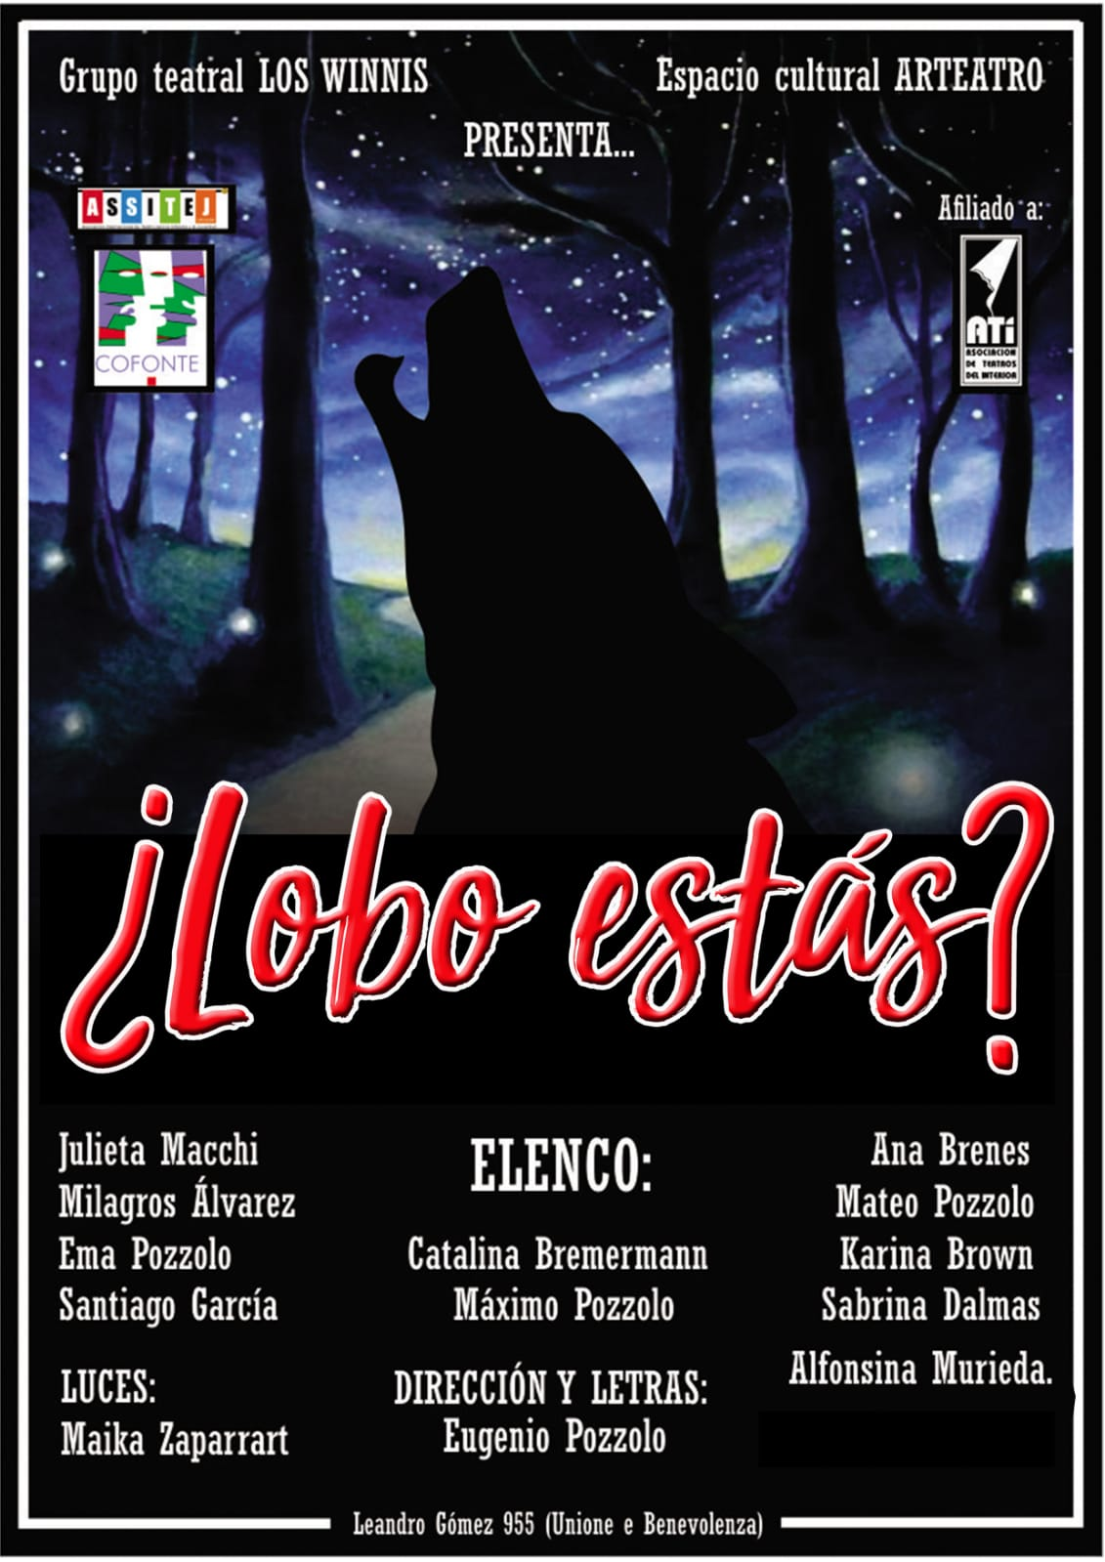
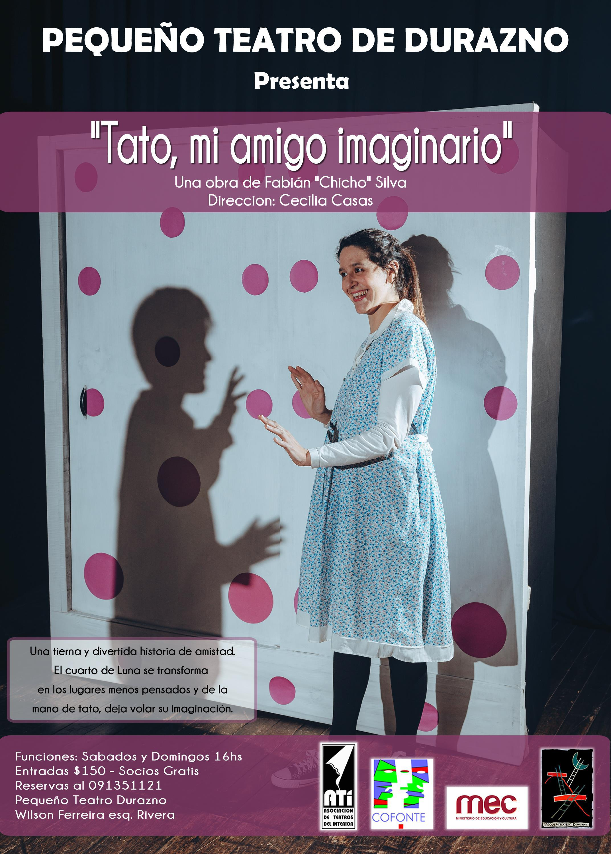
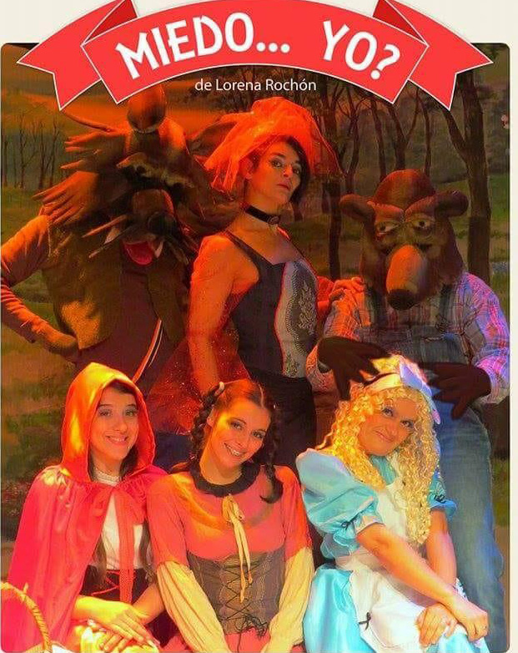

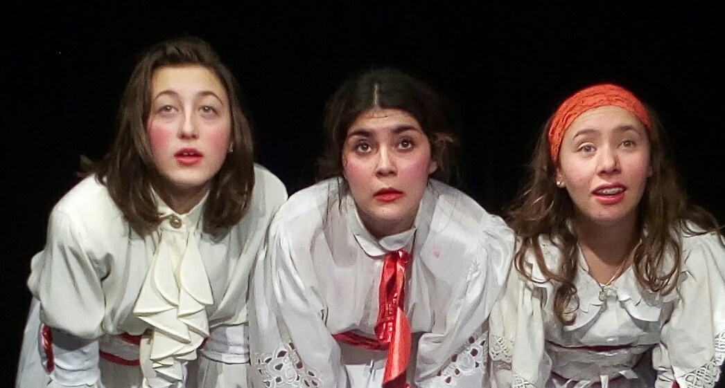






ATI AND ASSITEJ URUGUAY
present:
I Theater Encounter for Children and Youth of the Interior
and II Training Workshops

FUNCTIONS IN THE "FLORENCIO SÁNCHEZ" AND "ARTEATRO" ROOMS

FROM 20 TO 24 OCTOBER 2018
Saturday 20, at 4 p.m.
Sunday 21, at 4 p.m.
Monday 22, at 10.30 and 15.50.
Tuesday 23
Wednesday 24, at 10.30 and 15.30

Public and private schools and colleges must reserve their locations by calling Production on the cell phone ......

ASSITEJ is committed in its principles and practice to collaboration and cooperation with other international artistic associations in order to advocate for theater and the arts as universal expressions of humanity, fundamental to human, social and cultural development, and as forms of building bridges for understanding and tolerance as enshrined in the Universal Declaration of Human Rights.

Unlearn:

Collective creation, directed by Roberto Buschiazzo.

Three clown characters
they interweave their stories and their games to tell their experiences about the discovery of the adult world.
With the performances of: Antonella abellino, Florencia Arias and
Xamidra Nobelasco.
Duration: 40 minutes

A Hotel, an elephant and a few nonsense
Author: Federico Roca directed by Lorena Rochón.
For the group Municipal Comedy of Cologne

In the middle of the English countryside, a very special hotel and its staff live the vicissitudes of a great climatic storm and the mysteries that contain the desires of humans.
Six crazy characters, including a Uruguayan, experience the most insane situations, which will make everyone enjoy, inviting to know the great secret that they hide

Fear ... me?

Author: Lorena Rochón

The characters of the classic stories, always persecuted by fear, decide to make a turn in their lives. What do the wicked think about this? A different way of telling the old stories: Little Red Riding Hood, Goldilocks, Hansel and Gretel are encouraged to a profound change.

Tato, my imaginary friend

Author: Fabián "Chicho" Silva
By Durazno Small Theater

A new production of Pequeño Teatro under the direction of Cecilia Casas.
A tender and funny story of friendship, where the room of Luna is transformed into the least thoughtful places and Tato lets the imagination of all fly.
Act: Silvia Márquez, Alex Ozano, José Rossano,

Santiago Marreroy Guadalupe Márquez.

Are you there wolf?

By the group Los Winnis de Paysandú

The wolves in the tales of Little Red Riding Hood, Pedro and the wolf and The Three Little Pigs, got tired of the fact that only because they are wolves are they given evil stories in the stories. So they decide to install the debate on their roles in the stories and refuse to be pigeonholed in those roles.

ARLEQUINO: LORD OF TWO PATRONS

Comedy of art by Carlo Goldoni
Version and address: Lila García
For young people from 8 to 100 years old

The story is a succession of lies and misunderstandings, since Clarisa and Silvio are about to get married, and Truffaldino announces the arrival of his boss, Federico Rasponi, the bride's previous fiancé and who was believed dead. Indeed, the "dead" is his sister Beatriz, who, disguised as Federico, arrives in Venice in search of her boyfriend, Florindo Aretusi. Truffaldino finds this gentleman, also in need of a servant and taking advantage of the circumstances and with the need to calm the hunger, he is employed with the two bosses at the same time. Soon, the entanglement and entanglements will overcome the ability of the servant and his trick will be exposed.




